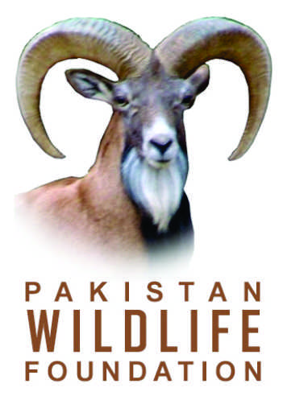

REGISTRATION FORM
SHORT TRAINING COURSE ON
TAXIDERMY & NATURAL HISTORY MUSEUM DEVELOPMENT
(March 28-30, 2013)
I want to join the training on taxidermy & natural history museum development being organized jointly by Pakistan Wildlife Foundation, Directorate of Biodiversity, Ministry of Climate Change and University of Veterinary and Animal Sciences, Lahore from March 28 to 30, 2013.
My contact details are as follows:
Name: …………………………………………………………………………….

PHOTO
Father’s Name: ………………………………………………………………….
CNIC No. …….………………………………………………………………….
Date of Birth: …………………………………………………………………….
Education: …………………………………………………………………….…
Occupation: ……………………………………………………………………..
Institution / Organization: …………………………………………………………………………………
Field of Interest: ………………………………………………………………………………………….
Postal Address: ……………………………………………………………………………………………
Phone Office: .……………………………….. Phone Residence: ………………………………..
Cell: …………………………………………… Email: ……………………………………………..

Date: …………………………………………….. Signature: …………………………………………

