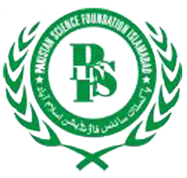
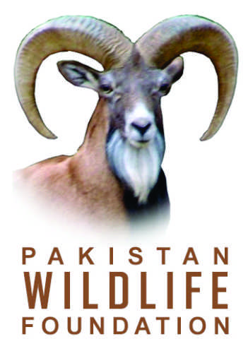

REGISTRATION FORM
Training Course on
Taxidermy & Natural History Museum Development
(September 2-6, 2013)
I want to join the training on taxidermy & natural history museum development being jointly organized by Pakistan Museum of Natural History and Pakistan Wildlife Foundation, from September 2-6, 2013.
My contact details are as follows:
Name: …………………………………………………………………………….

PHOTO
(Optional)
Father’s Name: ………………………………………………………………….
CNIC No. …….………………………………………………………………….
Date of Birth: …………………………………………………………………….
Education: …………………………………………………………………….…
Occupation: ……………………………………………………………………..
Institution / Organization: …………………………………………………………………………………
Field of Interest: ……………………………………………………………………………….………….
Postal Address: ……………………………………………………………………………………………
Phone Office: .……………………………….. Phone Residence: ……………………………..…..
Cell: …………………………………………… Email: ………………………………………….…..
Pay order / DD No. ……………………….…………… Amount Paid (Rs.) …………………………
Bank Name ………………………………………..………………..….… Date …………………….…

Date: …………………………………………….. Signature: ……………………………………..……
Please be informed that;
- Working lunch and tea will be served to the participants by the organizers during the training
- No TA & DA will be paid to any participant
- No accommodation will be provided to the participants

